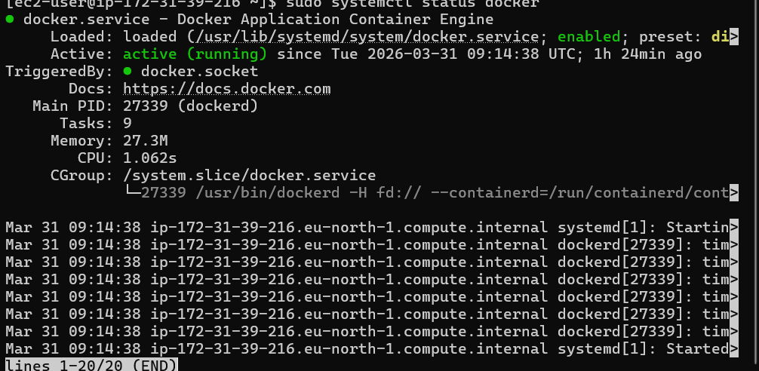

Successfully installed with dockers

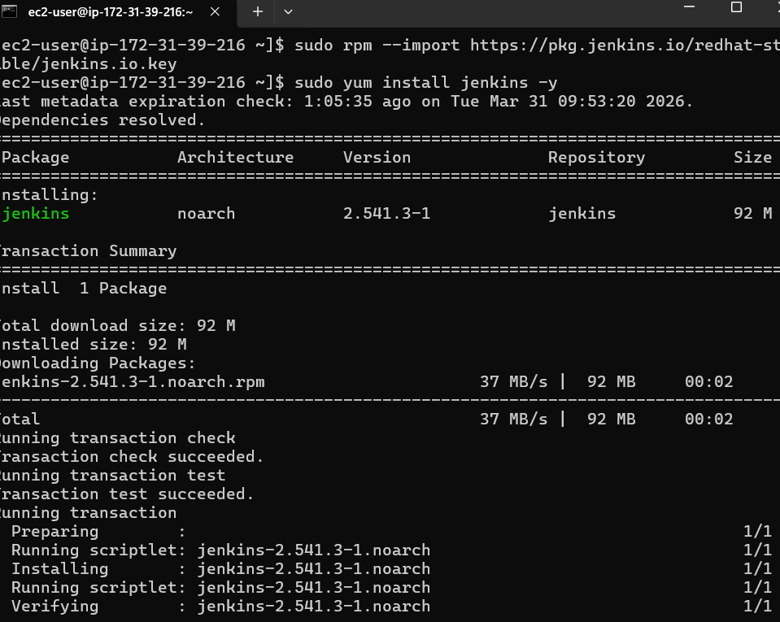
created Jenkins
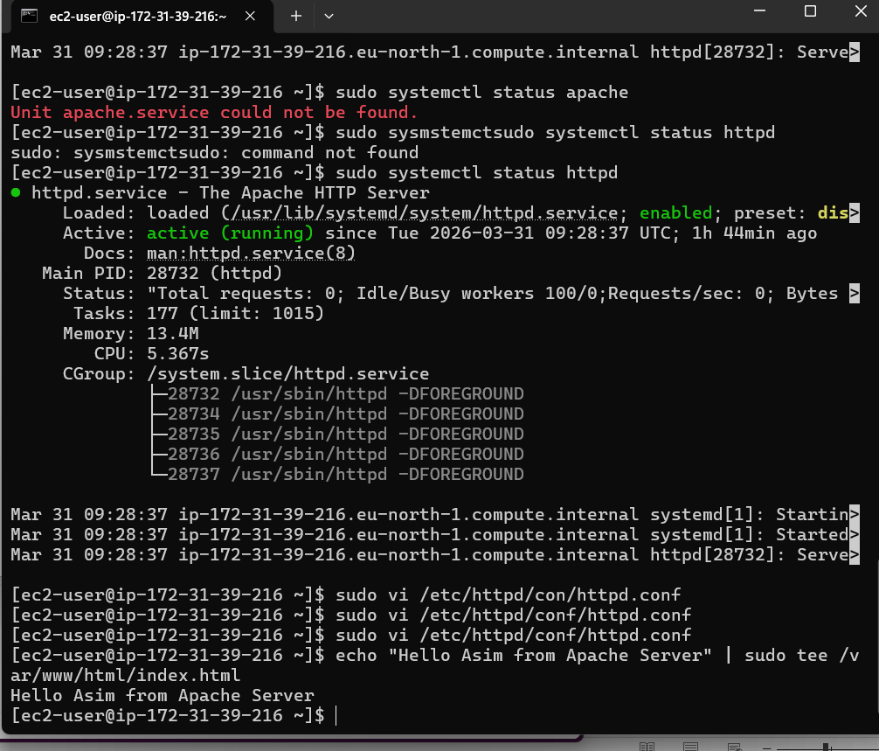

Created - Install Apache (httpd)
Changing the port number from 80 to 8082 as 80 is already in use.
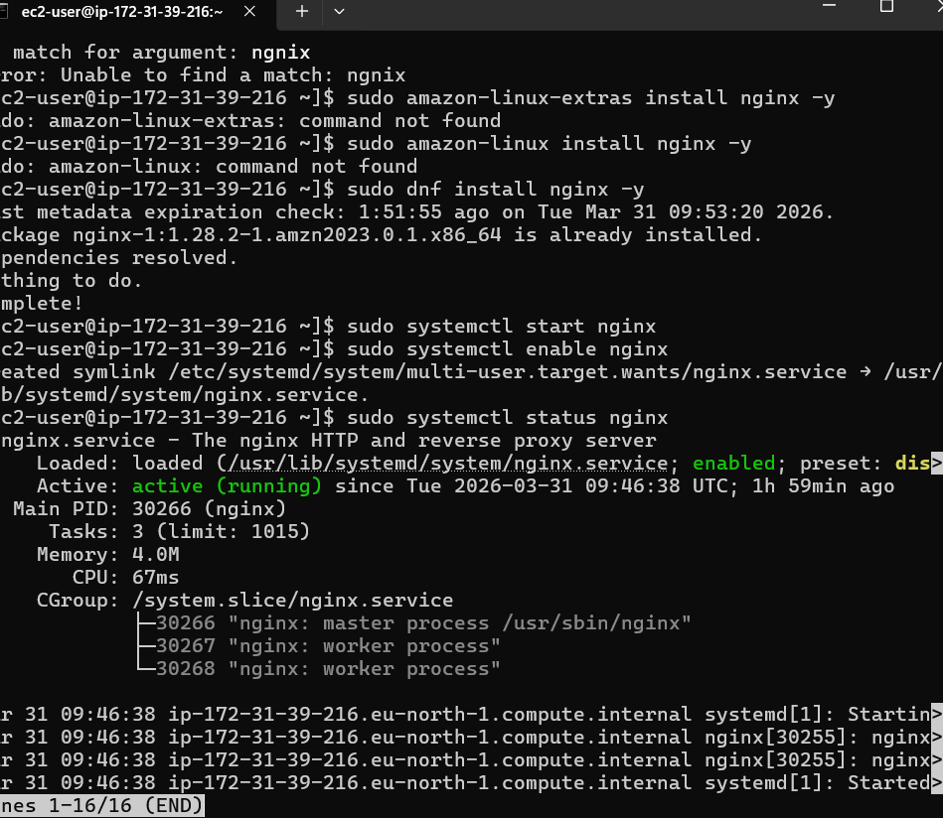

- Install Nginx
- We have changed the nginx port number to 8084

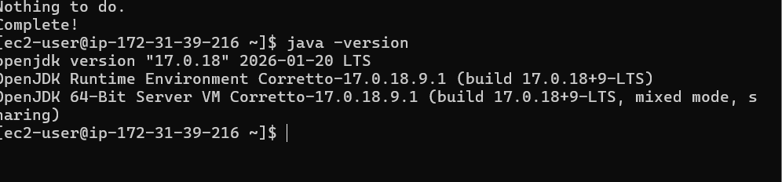
Checked the Java version for tomcat
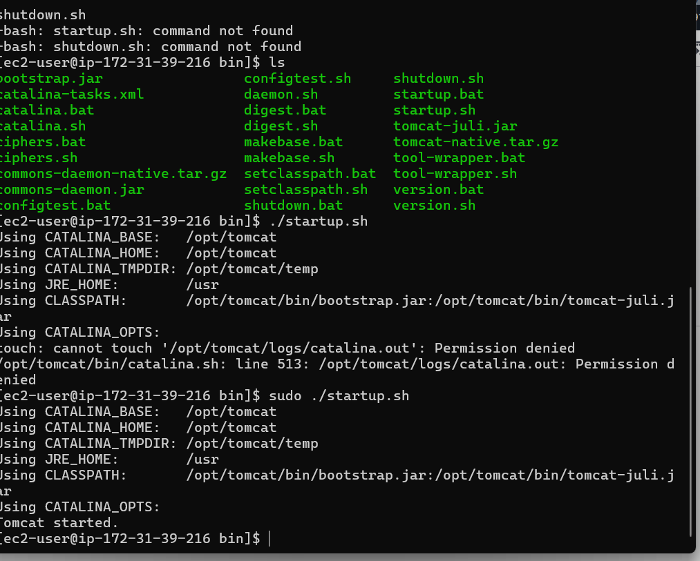
successfully created – Tomcat
Giving the execute permissions to execute startup script.
Tomcat server is now running on 8083
